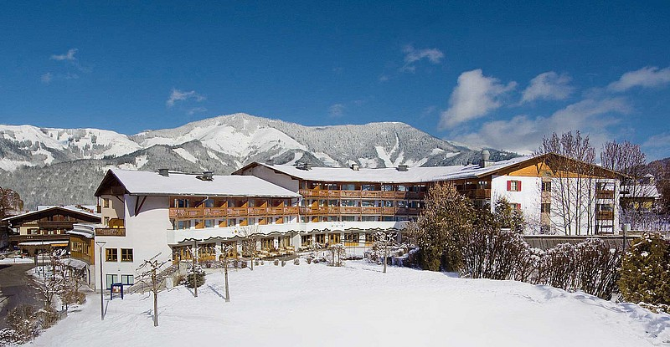

SETS 2018

Registration

Please fill-in this document and send it back to kristiane.schmitt@dfki.de

First name: |  | Last name:
Company: |  | Country:
Job title: |  | Phone number:
Email: |  | Fax:
Arrival date&time: |  | Departure date&time:

☐ The package price of 635 € includes:
- 4 nights in a double room for single use (February 19 to 23, 2018)
- 4 x breakfast
- 4 x dinner
- Social Event
- Conference room from February 20 to 22, 2018 (+ catering)
- Wifi

☐ The package price of 595 € includes:
- 4 nights in a double room for double use (February 19 to 23, 2018)
- 4 x breakfast
- 4 x dinner
- Social Event
- Conference room from February 20 to 22, 2018 (+ catering)
- Wifi
Note: The local tax of 1.15€ per day is not included in the package price and will be indicated separately. All other taxes are included.

Please indicate the name of the person with whom you wish to share your room:

First Name: Last Name:

Dietary restrictions (if any):
Special requests (if any):

Valid credit card details are required to guarantee the reservation:

Card Number: Expiry date:
Card holder name (first name, last name):
Signature: Date:

